Note: Include this page only when adding / amending / deleting a document. If using this document as a record, this Revision History page can be omitted.

REVISION HISTORY

Revision no | Date | Description of Changes | Reason for Revision | Revised by | Approvedby
2 | 19 Apr 13 | - Add revision history page  - Revise document name  - Revise reference & records list | - Recommendation from Stage 2 audit  - Results from the Business  Review Planning | RDPlacido
3 | 21 March 16 | - Added Disclaimer | - Printing is sole responsibility of the person who printed it | RCGanal | ECVentura

- Objective
To ensure that quality performance is maintained and any sign of decline will be detected and corresponding actions will be taken to eliminate causes of potential non-conformity

- Scope
This procedure defines the responsibility of the Unit Head and QMR in the analysis of data affecting quality performance to instigate proper preventive measures. The activities covered starts from the gathering of data on process performance to implementation of necessary actions to address result of data.

- Definition of Terms
QMR | Quality Management Representative
DC | Document Controller
KPM | Key Performance Measures are a set of quantifiable measures that the company uses to gauge or compare performance in terms of meeting its goals

- Procedure Details
RESPONSIBLE | ACTIVITY | INTERFACE
Unit Heads/QMR  QMR/ExeCom  DC  Unit heads/QMR | 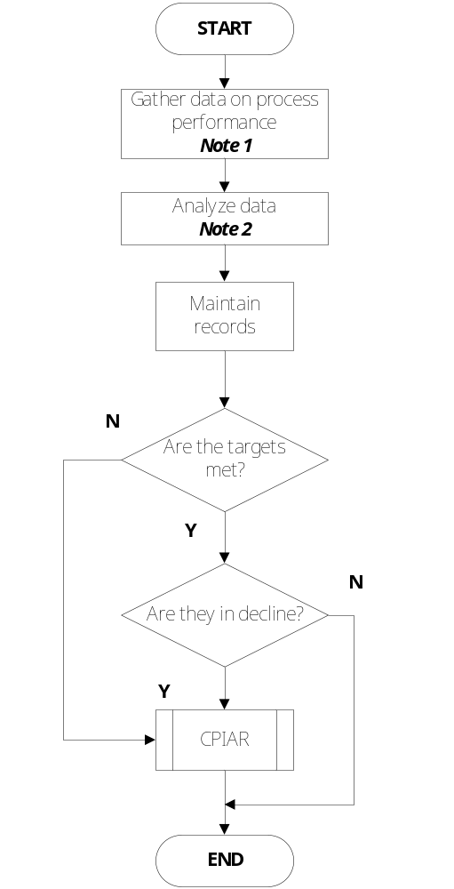 | KPM Monitoring Report  Management Review Presentation Slides  Minutes of Management Review  KPM Monitoring Report

Notes:
- The Unit Heads and QMR gather data on the performance of the department based on its KPI by updating the KPM Monitoring Report for that year. Performance of the department as to the attainment of its KPI is monitored through the KPM Monitoring Report.
- Data gathered are analyzed to check the ability of the process in meeting its KPI’s. Aside from the attainment of the targets, the trend of the process performance is also checked. Unmet target and declining process performance are reported through the CPIAR.

- References
- CPIAR
- ISO Mantis

- Quality Records
- ISO Mantis
- CPIAR
- KPM Monitoring Report
- Minutes of Monthly Management Review
- Presentation Slides of Monthly Management Review

